**Project Design Phase-II**

**Data Flow Diagram & User Stories**

| Date | 03 October 2022 |
| --- | --- |
| Team ID | PNT2022TMID42281 |
| Project Name | Project – Smart solutions for railways |
| Maximum Marks | 4 Marks |

**Data Flow Diagrams:**

A Data Flow Diagram (DFD) is a traditional visual representation of the information flows within a system. A neat and clear DFD can depict the right amount of the system requirement graphically. It shows how data enters and leaves the system, what changes the information, and where data is stored.





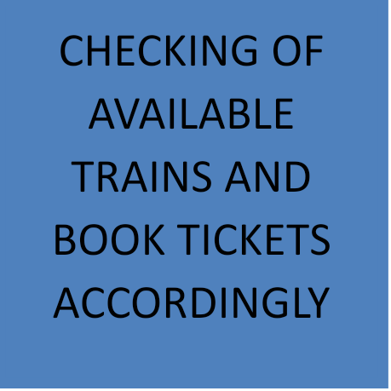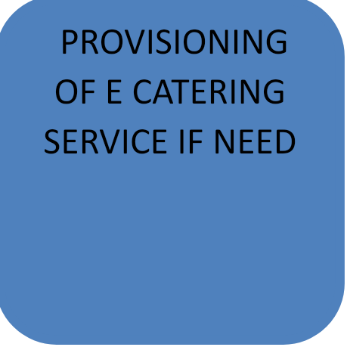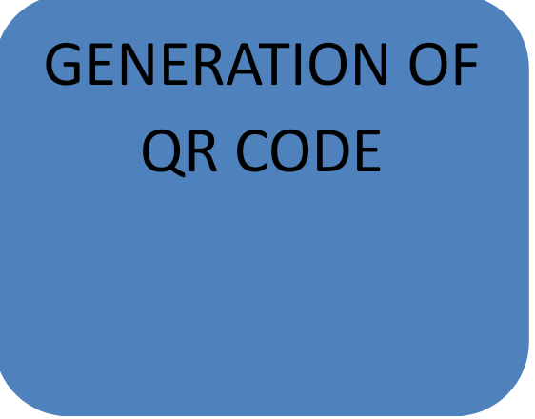



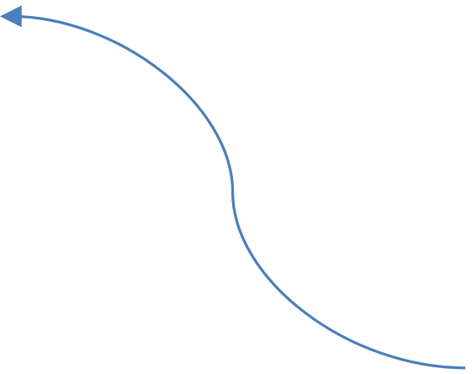

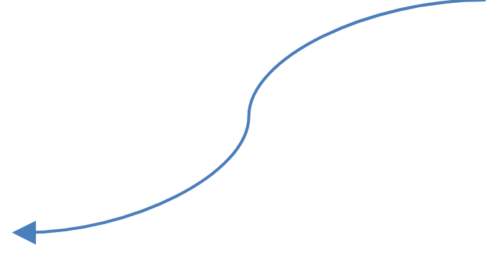

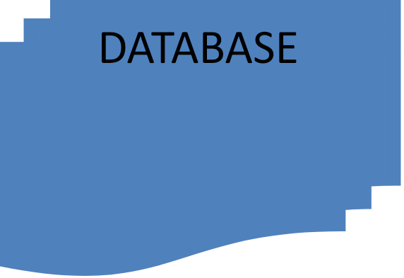





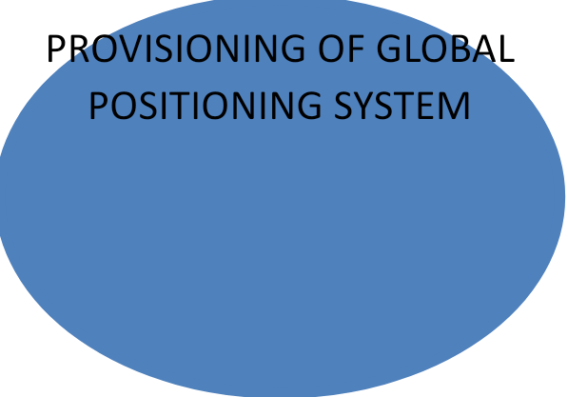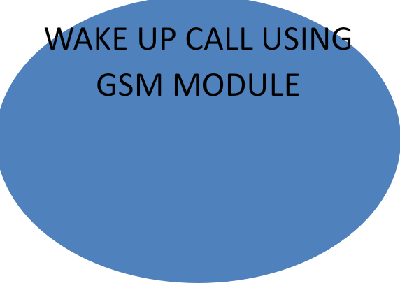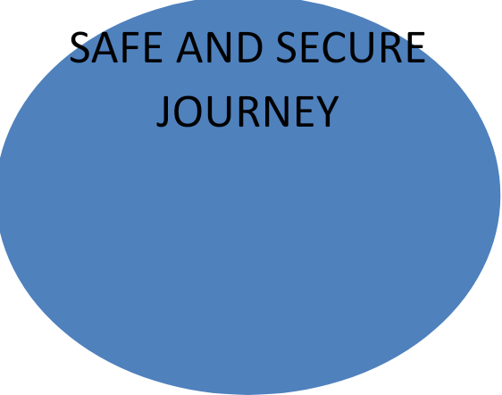

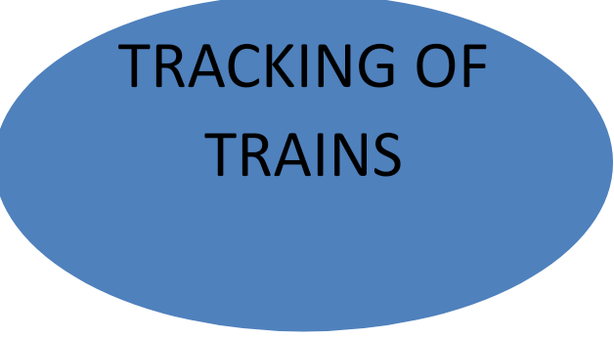



**User Stories**

List of all the user stories for the product.

| **User Type** | **Functional Requirement (Epic)** | **User Story Number** | **User Story / Task** | **Acceptance criteria** | **Priority** | **Release** |
| --- | --- | --- | --- | --- | --- | --- |
| Customer (Mobile user) | Registration | USN-1 | As a user, I can register in the website by entering my email,phone number,e-aadhar copy and some of my personal details. | The user can access their account without any problem. | High | Sprint-1 |
|  |  | USN-2 | As a user, I observed that the website has very few security-related problems. | The user will receive a confirmation email whenever their account is accessed and their private information is not leaked to others. | High | Sprint-1 |
|  |  | USN-3 | As a user, I can register in the website using my Google account. | The user can register & access the dashboard with Google account Login | Low | Sprint-2 |
|  |  | USN-4 | As a user, I can freely browse the choices of trains available to me and also their ticket vacancy. | The website should work smoothly when the user is browsing and provide results which satisfy the users. | High | Sprint-1 |
|  | Login | USN-5 | As a user, I can log into the website using my email and the password that I have set.Then I will have to enter a verification code which is sent to my email. | If the user has entered their email,password and verification code then they can login to their account smoothly.If they have forgot their password then forgot password option is also given. | High | Sprint-1 |
|  | Profile | USN-6 | As a user I can access my profile easily if I have logged into the website. | The user can change their personal information whenever they want effortlessly. | High | Sprint-1 |
| Customer (Web user) |  | WUSN-1 | As web user I am able to access the website and browse my options without logging in but to book tickets I have to register in the website. | The website should provide satisfactory results to the web user and should not crash suddenly. | High |  |
| Customer Care Executive |  | CCE-1 | As a customer care executive I can always contact customer using the phone number or the email address given in the website.I can also know about their problems in the website by acessing the issue option. | The customer care executive should be able assist the users by easily communicating with them. | High |  |
| Administrator |  | AMIN-1 | As a administrator I am able to access the list of users who have logged in to the website. | The details of the user should be given to the administrator impeccably when they request it. | High |  |
|  |  | ADMIN-2 | As a administrator I can access the number tickets which have been registered for a particular train. | The details about the number of tickets registered and the remaining tickets in a particular trian is accessible to the administrator along with the registered user's information. | High |  |
|  |  |  |  |  |  |  |
|  |  |  |  |  |  |  |